# Related works:

E-commerce platforms for handmade crafts and artisanal products have emerged as powerful tools to bridge the gap between local artisans and global markets. These platforms provide a space where small-scale producers can showcase their unique products, allowing them to reach a broader audience, gain economic independence, and preserve traditional craftsmanship. The development of such platforms involves integrating multiple technologies and considering various factors such as user experience, security, and scalability. Here we review the current state of related work in the field of e-commerce platforms for handcrafts, exploring existing systems, frameworks, and research contributions in the domain.

Society6 **:** A platform for independent artists to sell their designs on various products.

https://society6.com/

• Key **Strengths:**

* Wide range of product options, including home decor, apparel, and accessories.
* Print-on-demand model, reducing inventory costs for artists.
* Strong focus on design and aesthetics.

• Potential **Weaknesses:**

* Less emphasis on traditional crafts and handmade items.
* Competition from other print-on-demand platform

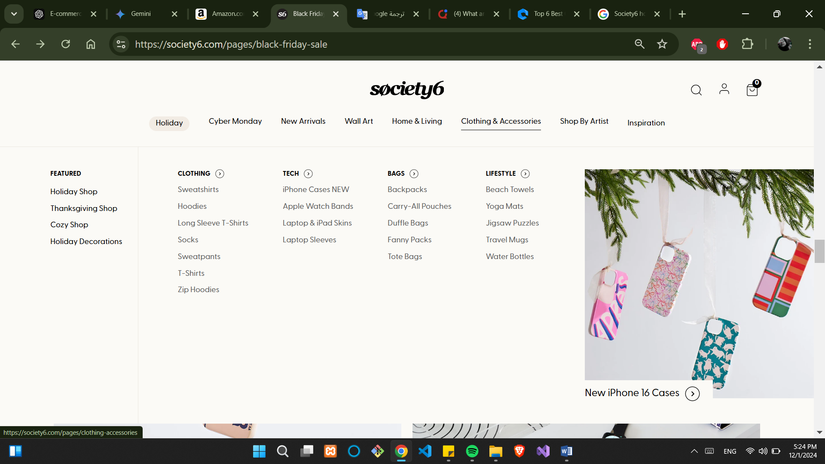

## 1.1 **Etsy**

Etsy is one of the most prominent e-commerce platforms that specialize in handmade, vintage, and unique items. Since its launch in 2005, Etsy has empowered artisans worldwide to sell their handcrafted goods to a global market. The platform has been instrumental in connecting buyers with small-scale creators, making it an important case study for understanding the success and challenges of online marketplaces for handmade products. Etsy’s business model focuses on offering sellers a user-friendly platform to list their products, manage payments, and engage with customers, while ensuring buyers have a secure, trusted shopping experience

### <https://www.etsy.com/>

### Key Strengths:

* **User-friendly interface** for buyers and sellers.
* Strong community and social features.
* Diverse product range

### Potential Weaknesses:

* **High competition**, especially for popular categories.
* **Seller fees can be significant**: Etsy charges merchants 7% of sales plus a $0.30 per item processing fee. This can add up quickly and given the high-volume nature of many shops, it can be difficult for smaller businesses to keep up with expenses."
* **shipping costs** on Etsy can also be expensive compared to other online platforms like Amazon or eBay.
* since most items sold on Etsy are handmade, there is often a **delay in receiving** products due not only to production time but also delivery time from overseas suppliers.

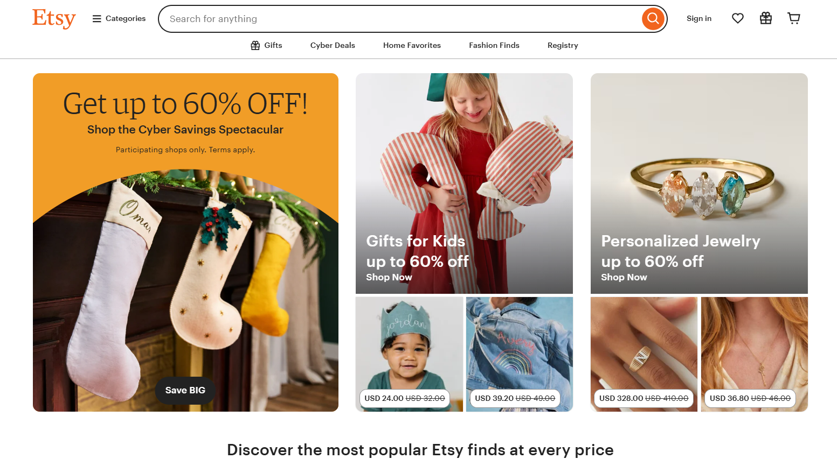

Figure Etsy platform

#### 1.2 **ArtFire**:

#### ArtFire is another e-commerce platform catering to artisans and craft sellers. Founded in 2008, ArtFire offers a variety of tools for sellers,. Unfortunately, the platform officially closed in December 2021 due to operational challenges, Over its 13-year history, ArtFire helped artists and crafters generate over $250 million in sales globally. Despite its closure, ArtFire is remembered for its contribution to the artisan community, enabling small businesses to thrive

## Key Strengths:

1. Pricing Structure: ArtFire offers a straightforward pricing structure with a flat monthly fee, eliminating listing fees and commissions on sales. This can be advantageous for sellers who prefer predictable costs or have high-volume sales.
2. Customizable Storefront: ArtFire provides sellers with the ability to customize their storefronts to match their branding and showcase their products uniquely. This can help create a more personalized shopping experience for customers.
3. Search Engine Optimization (SEO): ArtFire places a strong emphasis on SEO and provides tools and guidance to optimize product listings for search engines. This can potentially improve visibility and attract more organic traffic to sellers' stores.

### Potential Weaknesses:

* Lower Traffic and Market Reach: Compared to Etsy, ArtFire generally receives less overall traffic and has a smaller user base. This may result in fewer potential customers and lower sales volume for sellers.
* Limited Community and Social Features: ArtFire's community and social features are not as robust as those on platforms like Etsy. Interaction between sellers and buyers, as well as seller-to-seller networking, may be more limited.
* Smaller Product Variety: ArtFire focuses more on handmade and artisan products, which can result in a narrower range of product categories compared to platforms like Etsy. Sellers with products that fall outside the traditional handmade realm may find a smaller target audience on ArtFire.

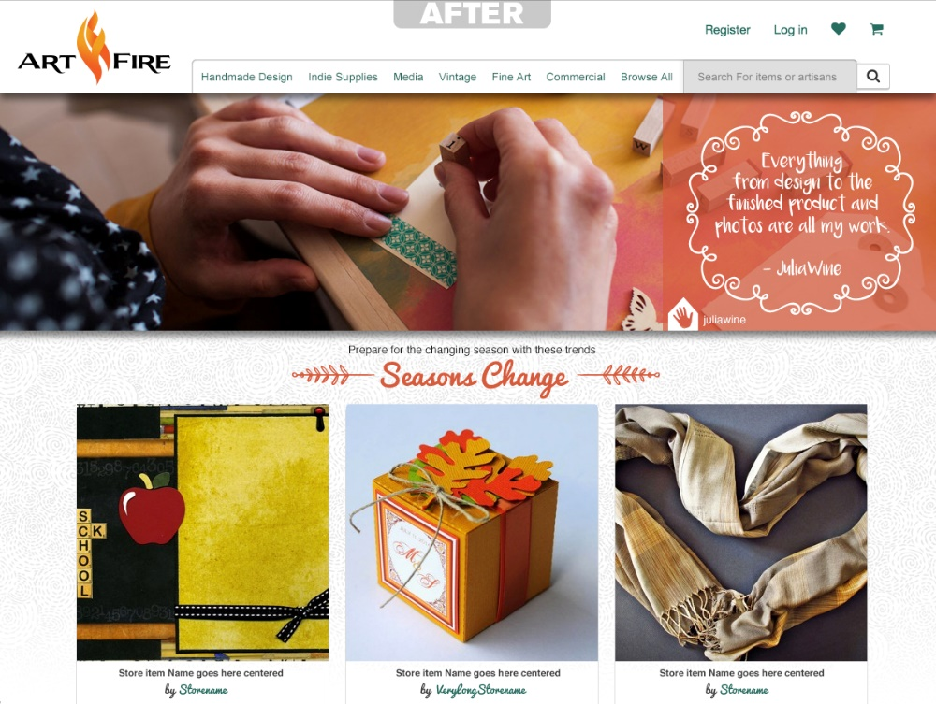

Amazon Handmade is a curated marketplace within Amazon, dedicated to unique, handcrafted products from artisans around the world. It offers a platform for sellers to showcase and sell their handmade goods directly to consumers.

https://www.amazon.com/ref=nav_logo

Strengths**:**

* **Massive Reach:** Leverages Amazon's vast customer base to reach a global audience.
* **Established Platform:** Benefits from Amazon's trusted brand and infrastructure.
* **Fulfillment Services:** Offers integration with Amazon's Fulfillment by Amazon (FBA) service for efficient shipping and logistics.
* **Marketing and Advertising Tools:** Provides access to Amazon's marketing and advertising tools to help sellers promote their products.
* **Customer Trust:** Leverages Amazon's customer trust and established payment and return policies. **Promote Ethical Consumption:** To encourage consumers to choose ethical and sustainable products.

### Weaknesses:

* **High Competition:** A large marketplace with many sellers, making it challenging to stand out.
* **Fees:** Amazon charges fees for listing products, referrals, and storage, which can impact profit margins.
* **Brand Dilution:** Potential for brand dilution as products are listed alongside other sellers.
* **Strict Guidelines:** Adherence to strict handmade guidelines and quality standards can be time-consuming.
* **Limited Customization:** Less customization options for seller storefronts compared to other platforms.

